Software Detailed Design Approval:

|  |  |  |  |  |  |  |  |
| --- | --- | --- | --- | --- | --- | --- | --- |
| Issued by:  DEV |  | Sridhar Manickavel |  |  |  |  |  |
|  | Name printed |  | Signature |  | Date |  |
| Revision No.: | 01 | | | | | | |
| Approved by  PL/PM: |  | Diksha Babhoota |  |  |  |  |  |
|  | Name printed |  | Signature |  | Date |  |
| Approved by  Product Manager: |  | Matthew Carter |  |  |  |  |  | |
|  | Name printed |  | Signature |  | Date |  |
| Approved by  RA/QA: |  | Sreejith Viswam |  |  |  |  |  |
|  | Name printed |  | Signature |  | Date |  |
| Approved by  R&D: |  | Ezhil Ilanko |  |  |  |  |  | |
|  |  | Name printed |  | Signature |  | Date |  |

Project Number: SGTC-NPD-007, Project Name: Knee Balancer

Knee Balancer

Version Number: 01

D007010070

Table of Contents

1 Introduction 4

1.1 Purpose 4

1.2 Scope 4

1.3 Definitions, acronyms and abbreviations 4

1.4 References 5

2 System / Component Context 5

3 System / Component Decomposition 7

3.1 Module Decomposition 7

3.1.1 Frontend Module 8

3.2 Concurrent Process Decomposition 12

3.3 Data Decomposition 12

3.3.1 Case Details 12

3.3.2 Logs 14

4 Interface 15

4.1 Interface with external hardware components 15

4.2 Interface with external software components 16

4.3 Interface between modules 16

5 Detailed Design 16

5.1 Home Module 16

5.2 Case input module 16

5.3 Case Solution Module 19

5.4 User Preference module 20

5.5 Case Identifier module 24

5.6 Algorithm 25

5.7 Target device 26

6 Detailed Process Design 26

7 Detailed data design 26

7.1 Data flow Diagram 26

7.2 View Preference : 26

7.3 Solution : 27

7.4 Locking and Unlock features 27

7.5 Camera capture : 28

7.6 Core DataBase 30

7.7 Initial Position 31

7.8 User preference 31

7.9 Solution 31

7.10 Upload Module 31

7.11 Backend -Cloud 33

7.12 Authentication Module: 33

8 SOUP items 34

9 SECURITY 34

10 XCODE Configuration 34

11 Document Revision History: 34

12 Appendix 35

12.1 Example of Case Data file 35

12.2 Example of Error or Exception logs file 38

12.3 Example of Events log file 38

12.4 Complete event list captured in the application 39

# Introduction

## Purpose

This document describes how the Knee Balancer application is structured in order to satisfy the requirements identified in the SRS. It describes the software structure, sub-components, interfaces, and data necessary for understanding the functioning of the software system.

The intended audience for this document is development, regulatory affairs and quality assurance.

The Knee Balancer application is intended to improve the efficiency that is involved with calculating the implant movements required during TKA intra-operative balancing. The app is a clinical decision support software tool which provides on demand, an automated intra operative plan to the Orthopaedic surgeon based on pre-operative data, captured soft tissue information and surgeon preferences.

## Scope

Operating principle The Knee Balancer application is a clinical decision support software tool which provides a list of possible TKA implant positions intra-operatively that achieve the surgeons desired knee laxity for an individual patient, using the initial plan and initial knee laxity values as inputs.

Please refer Intended Use document [IU] for more details.

The system supports surgical knee procedures, including: - Total Knee Arthroplasty (TKA)

* The Knee Balancer app will be designed for iPhone and iPad
* The app provided to Stryker via Stryker App Store
* Product security
* Solutions are derived based on the surgeon's target gap/laxity

App includes

* Case input – Gap, alignment angle, rotation angles, resection depths, limb varus/valgus angle and limb flexion angle
* Case solution
* Surgeon/User preferences
* Case identifier
* Uploading application logs, input and output parameters to cloud
* Mako robotic system screen recognition

Out of scope

* Digital connection to the other system (Bluetooth)
* Medical image data intake
* Download case information and send email
* Record position page
* Mid resection surgeon preference

## Definitions, acronyms and abbreviations

|  |  |
| --- | --- |
| Term | Definition |
| UML | Unified Modelling Language |
| MAKO | Robotic-Arm Assisted Surgery |
| MA | Mechanical Alignment |
| FA | Functional Alignment |
| IA | Individualized Alignment |
| HKA | Hip Knee Ankle Alignment |
| STR | Soft Tissue Release |

## References

|  |  |  |
| --- | --- | --- |
| **ID** | **Title** | **Doc. No.** |
| URS | USER REQUIREMENTS SPECIFICATION | D007010058 |
| SRS | SOFTWARE REQUIREMENTS SPECIFICATION | D007010059 |
| SAD | SOFTWARE ARCHITECTURE DESIGN | D007010025 |
| DDP | Design and Development Plan | D007010004 |
| SOUP | Software Soup description | D007010081 |
| SAD_ALG | SOFTWARE ARCHITECTURE DESIGN - Algorithm | D007010094 |

# System / Component Context

The pre-operative data or the initial plan along with the Surgeon preference values are entered into Knee Balancer application by manual input or the initial plan can be image captured from the Mako system by MPS.  Based on the input values, Knee Balancer application generates solutions for the preferred gap values.  MPS will discuss the available solutions with Surgeon before entering the solution position into the Mako system.  Also, surgeon can assist MPS to change the input values and generate solutions again if required.  Knee Balancer application will not confirm/verify the selected solution is used in the Mako surgery or not, it is out of scope for Knee Balancer application.

Knee Balancer application will not store any PHI data within the application or in the cloud.

System diagram is as shown below



This chapter defines the borders between this system and its neighbouring systems. It identifies all external interfaces between those.

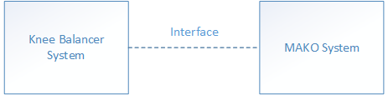

|  |  |
| --- | --- |
| Neighbouring System/Component | Description |
| Neighbouring System/ Mako system | Provides the plan and the input data to the MPS user. MPS user reads the values and enters the input data into the Knee Balancer system to generate solutions. |
| Interface | MPS user has read the value manually or they can use camera capture to read the values from Mako system |

# 

# System / Component Decomposition

**Over all Software System**

Knee Balancer application is developed only for iPhone and iPad Stryker users. This application allows to enter the values only through manual input or through photo image where application process and reads the input values. Additionally, application archives the logs and case input/output to Azure blob

storage

## Module Decomposition

Each module of the system is described in the module level diagram below

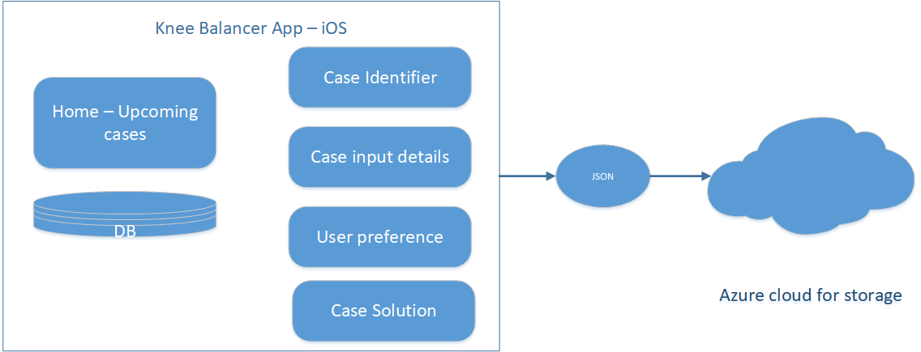

### Frontend Module



The Knee Balancer application consists of 5 main modules

|  |  |  |  |
| --- | --- | --- | --- |
| *SDD ID* | Module | Description | SAD ID |
| SDD100 | Home | As soon as application is open, the application checks the available phone memory and indicates if it is lower than 100 MB, before opening Home screen  Home screen displays upcoming cases and allow to add new case details. This module also provides searching capabilities. Can select user preference from the standard preferences  User can select TKA 1.0/ TKA 2.0 options before moving to view or adding the case details.  While creating a new case if any Active case is exists user is reminded with the message box.  Provide user to schedule or plan a case with case details which is sorted date wise and run unscheduled cases without case details through quick start option.  Below are the options provided in Hamburger menu,   * Sign in * User manual * About application | SAD100, SD100 |
| SDD101 | Case input | Case input screen allows the user to input femoral pre-operative plan data including medial distal femoral, lateral distal femoral, medial posterior femoral, lateral femoral posterior resection depths, femoral component varus/valgus and internal/ external rotation, and tibial pre-operative plan data including medial proximal and lateral proximal tibial resections and tibial component varus/valgus.  Allows to add intra operative data like medial extension gap, lateral extension gap, medial flexion gap and lateral flexion gap. Or User can input through camera capture All values are captured automatically except mHKA parameters which needs to be entered manually. The default preference is already selected, which can be modified from the available preferences.  A message is displayed to user to review and compare for accuracy to rule out any error due to automatic capture. Refer sec 7.5 for more details on camera capture  User can choose leg side, Surgeon, preference from the case settings. Users have option to reset the data and update case data.  Refer section 3.4.1 for more details | SAD101, SD101 |
| SDD102 | Case solution | Once all the input parameters are entered and the required preference are selected can generate solution. From solution screen user can see the best solution provided by the algorithm. (Refer sec 5.6 for algorithm details) User can view other solutions by changing the parameters to get his required solution. User can check the delta values compared to initial position. User can select different preference and generate solution again. User can re-enter input values and generate solutions again.  Solution also displays the poly insert message if Tibia resection is distalised.  The solutions displayed are within the STR 5 mm range. If it exceeds the STR 5 mm then there will not be any solutions displayed.  The solution also indicates if the parameters values are over limits and also if there is any STR within 6 mm  Required parameter can be locked while making adjustments to the solution until desired solution is reached.  User friendly features such as unlock to go the previous set of parameters are also available  Solutions can be regenerated by changing input values and changing preference from the initial position screen. If any changes made in initial position screen may have to mandatorily solve to regenerate and move to new set of solutions  After exiting all case details are logged and stored in the local database until pushed to cloud. Refer sec 6.6 for database details.  Only authorised user is allowed to push to cloud. Refer Security section-9 for more details  User can navigate to first solution from the reset option.  The case can be exited if the user accepts the solution which is logged and once case data is uploaded to cloud the data will be deleted from the local database. Refer sec 3.4.2 for case data logs details  If the case is not uploaded for 30 days the app will be locked for further use until the device comes online and the past data is uploaded  Before existing the case the application reminds user   1. To see if there is mandatory hospital field 2. To review and confirm results with surgeon 3. To review case details if coming from quick start | SAD102, SAD105, SAD108, SD102, SD103, |
| SDD103 | Surgeon/ User preference | Allows user to check the following planning ranges for the femoral component to be used during generation of automated implant plan:  coronal alignment (Varus/Valgus), transverse alignment (I/E Rotation), medial lateral distal and posterior resections.  Allows the user to check planning targets and ranges for the tibial component to be used during generation of automated implant plan:  Coronal alignment (Varus/Valgus)  medial lateral tibial resections. Allows user to input Planning targets for ideal final gaps (target).  Standard preferences are - MN (Mechanical Narrow), MW (Mechanical Wide), IN (Individualised Narrow), IW (Individualised Wide**)**  User can create custom preference per surgeon and modify target gaps or laxity as per the surgeons need during case planning. User is allowed to create a custom preference during the surgery or in the solution screen after user needs to click solve again.  The standard preferences changes asper the TKA 1.0 and TKA 2.0 options. User can see all the preferences in the preference list.  Refer sec 5.4 – user preference module for ranges of user preferences | SAD103  SD105 |
| SDD104 | Case identifier | Application allows to add the following details Case Identifier, Surgeon name, Hospital name, Surgery date.  Each case is internally stored with unique ID which is different from case identifier manually entered by user. All the case related data like solve time, exit time, user details are linked to unique id in addition to the input values, preference and solution values.  All these information is stored in JSON file in the local device. Past cases are stored locally for up to 30 days only if the device is not connected to internet and not authenticated to Azure AD. If device is connected to internet, then on case completion details are sent to cloud which will be stored for about 90 days in cloud.  Once the case details are entered it is confirmed with the user before saving. | SAD104, SD106 |
| SDD107 | About Screen | Contains information about the User manual, software version and Application details. | SD104 |

## Concurrent Process Decomposition

The main process thread running on the app is the UI thread. UI thread calls all system resources as per the events. When the system comes online runs parallel thread to punch the data to cloud.

## Data Decomposition

### Case Details

Case details can be stores with the combination of identifier data, user data, Preference details, Case Input details, Case Solution details.

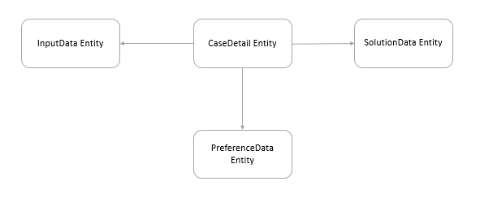

Every case consists of following details as mentioned in the table below

|  |  |
| --- | --- |
| Data Unit | Description |
| User Details | Stores user information’s |
| Preference Details | Stores user preference details |
| Input Details | Stores input details |
| Solution Details | Stores solution details |
| Add Case | Stores Case Id, Surgeon Name, Hospital Name, leg Alignment, Selected Preference, Solve Time, Exit Time details |

**Add Case:**

The set of parameters stored as part of the case identification. Hospital name and Surgeon name are mandatory field and surgery date is default to today’s date while adding new case or while modifying the case details. Additionally, user can enter surgeon name and case identifier. Following are the additional parameters stored as part of the case details

|  |
| --- |
| CaseId |
| SurgeonName |
| HospitalName |
| SurgeryDate |
| LegAlignment |
| SolveTime |
| ExitTime |
| SelectedPreference |

**User Data**:

User Data is collected while authenticating with Azure AD and same information will be stored in the user data. The name and email id are stored as in the table below,

|  |
| --- |
| MPS Name |
| Email Id |

**Preference:**

User can select standard preference or can create custom preference which will store following set of values as shown in the table below

|  |  |
| --- | --- |
| preferenceName | limitsFemAlignmentTarget |
| dynamicMedialResectionLimits | limitsFemAlignmentTargetIsInitial |
| dynamicLateralResectionLimits | limitsMaxFemValgus |
| limitsMinMedExtGap | limitsMaxFemInternal |
| limitsMinLatExtGap | limitsFemRotationTarget |
| limitsMinLatExtGap | limitsFemRotationTargetIsInitial |
| limitsMinMedFlexGap | limitsMaxFemExternal |
| limitsMinLatFlexGap | limitsMaxTibVarus |
| limitsTargetMedExtGap | limitsTibAlignmentTargetIsInitial |
| limitsTargetLatExtGap | limitsTibAlignmentTarget |
| limtsTargetMedFlexGap | limitsMaxTibValgus |
| limitsTargetLatFlexGap | limitsMaxHKAVarus |
| limitsMaxMedExtGap | limitsMaxHKAVarus |
| limitsMaxLatExtGap | limitsHKAAlignmentTarget |
| limitsMaxMedFlexGap | limitsHKAAlignmentTargetIsInitial |
| limitsMaxLatFlexGap | limitsMaxHKAValgus |
| limitsMaxFemVarus | limitsFFDCompInitial |

**Case Input:**

Input position details can be entered manually using the editor pop up in the application using gestures on the image or using the up/down buttons. These parameters can also be captured from the device camera by clicking the MAKO images. Following parameters can be entered as shown in the table

|  |  |
| --- | --- |
| operativeSide | initialTibProxMedResection |
| initialFemAlignment | initialTibProxLatResection |
| initialFemRotation | initialMedExtGap |
| initialTibAlignment | initialLatExtGap |
| initialFixedFlexion | initialMedFlexGap |
| initialmHKAAlignment | initialLatFlexGap |
| initialaHKAAlignment | originalMedExtGap |
| initialJLO | originalLatExtGap |
| initialCPAKGroup | originalMedFlexGap |
| initialFemDistMedResection | originalMedFlexGap |
| initialFemDistLatResection | originalLatFlexGap |
| initialFemPostMedResection | originalLatFlexGap |
| initialFemPostLatResection | algorithmResolution |

**Case Solution Details:**

User can generate solutions and the following set of parameters get affected as shown in the table below

|  |  |
| --- | --- |
| solvedLatFlexGap | medialEpicondylarDrift |
| solvedFemAlignment | suggestedSoftTissueRelease |
| solvedFemRotation | requiredMedialExtensionRelease |
| solvedTibAlignment | requiredLateralExtensionRelease |
| solvedHKAAlignment | requiredMedialFlexionRelease |
| solvedFemDistMedResection | requiredLateralFlexionRelease |
| solvedFemDistLatResection | totalResults |
| solvedFemPostMedResection | resultsWithOutSTR |
| solvedFemPostLatResection | resultsWithSTR |
| solvedTibProxMedResection | resultsOverLimits |
| solvedTibProxLatResection | calculationVersion |
| solvedMedExtGap | lateralColumnLength |
| solvedLatExtGap | midRangeLaxity |
| solvedMedFlexGap | proximityToInitial |

### Logs

Logs details will be stores with the combination of Error details, crashing details, Exception details and Event logs

* Error log/ Exception Logs
* Event logs (Tracking)
* Case data logs

To get the logs from the device needs MAC machine or iTunes software to download from the device. Or can download the logs when it is pushed to cloud by the post marketing team

Logs are pushed to cloud whenever the device comes online and if there is past case data waiting for upload. As soon as user provides his credentials and if past case data is available all the logs are pushed to cloud. Refer section 6.10 upload module for more technical details

Since the application is designed to run on offline mode, a reminder is set every day at least twice in a day when user opens app and comes to home screen to sign in so that the past data collected is pushed to cloud. If the data is not pushed to cloud the case logs are deleted in 30 days locally. For every 12 hours user can see fly message to upload the data up to 30 days. Once the logs are uploaded to cloud it is deleted in local device database. If the logs and case details are not uploaded to cloud within 30 days, application will display message to user to connect internet within 24 hours. And if the device is not connected within 24 hours, then system will block the application to use and user has to connect forcibly to internet to push the logs.

**Error log/ Exception Logs**

Error handling and exception handling are achieved by using default swift features those are listed below - Do catch block, throw, try, guard let, if let.

This captures any error or exception occurred in the application along with the date time stamp. This is stored in the local device for 30 days and is pushed to cloud which remains for 90 days for the complaint analysis.

Please see the appendix section for the example of error/ exception log

**Event logs (Tracking)**

The app also captured every event of the application and logs for tracking the events. This log captures every event along with case id and user details along with date and time stamp

Refer the appendix section for the complete list of events which will be logged in the application

Refer the appendix section for the example of event logs

**Case data logs**

When user exits case, it becomes past case and is stored in local database for 30 days until the device is online and pushed to cloud. If case is not uploaded within 30 days, it gets deleted from the device. The case data consists of case identification, user data, preference, input positions and solutions.

Every case consists of 2 set of all three – preference, input positions and solutions – one for first solution or default solution and the other for the modified solution or the accepted solution while exiting the case

Case log does not contain any sensitive information such as keys/certs, credentials, Patient data, etc.,

# Interface

## Interface with external hardware components

Input parameters are taken from MAKO system manually by the MPS user either reading from MAKO or taking camera picture from MAKO

## Interface with external software components

Azure cloud is interfaced through or is accessible from anywhere in the world over HTTP or HTTPS. The data is transmitted via JSON format.

## Interface between modules

Modules are interfaced within the objects through function calls

# Detailed Design

## Home Module

Home screen includes upcoming cases to show added case details of patients.

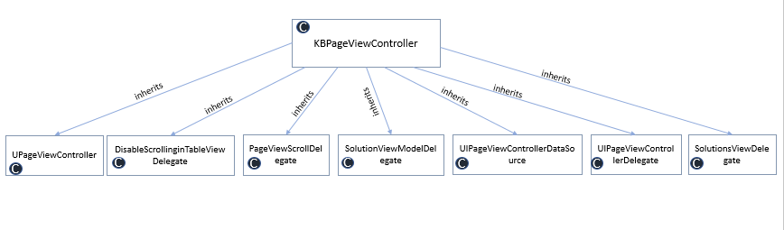

## Case input module

Case input screen allows the user to input femoral pre-operative plan data including medial distal femoral, lateral distal femoral, medial posterior femoral, lateral femoral posterior resection depths, femoral component varus/valgus and internal/ external rotation, and tibial pre-operative plan data including medial proximal and lateral proximal tibial resections and tibial component varus/valgus.

|  |  |  |  |  |
| --- | --- | --- | --- | --- |
| **Parameters** | **Min** | **Max** | **Steps** | **Default** |
| **Distal Femur** |  |  |  |  |
| Coronal Alignment Limits | 17 valgus | 15 varus | 0.1 (small steps) *  1 (large steps) | 0.0 |
| Medial Resection Limits | -2 | 15 | 0.5** | 7.0 |
| Lateral Resection Limits | -3 | 15 | 0.5** | 7.0 |
| **Posterior Femur** |  |  |  |  |
| Rotational Alignment Limits | 15 internal | 15 External | 0.1 (small steps)*  1 (large steps) | 0.0 |
| Medial Resection Limits | -2 | 15 | 0.5** | 7.0 |
| Lateral Resection Limits | -2 | 15 | 0.5** | 7.0 |
| **Proximal Tibia** |  |  |  |  |
| Coronal Alignment Limits | 15 valgus | 15 varus | 0.1 (small steps)*  1 (large steps) | 0.0 |
| Medial Resection Limits | -5 | 15 | 0.5** | 7.0 |
| Lateral Resection Limits | -2 | 15 | 0.5** | 7.0 |
| **mHKA And Scoring** |  |  |  |  |
| Hip Knee Ankle Alignment Limits | 26 valgus | 19 varus | 1 | 0.0 |
| Hip Knee Ankle Flexion limits | 21 Extension | 33 Flexion | 1 | 0.0 |

*Small steps – for fine changes can be used by buttons

*Large steps – for coarse changes can be used by gestures.

**Changes for M & L is done together for gesture movements. For individual changes may have to use buttons. Gesture cannot be used if any M or L has reached maximum. M & L values are stopped together at a value which is lower max of both. The remaining value can be modified using push buttons

Allows to add intra operative data like medial extension gap, lateral extension gap, medial flexion gap and lateral flexion gap Or User can input through camera capture All values except mHKA parameters

User can feed Input data in two modes TKA 1.0 and TKA 2.0

In TKA 1.0 gaps ranges are 0 to 40 mm and default gaps are 20 mm.

|  |  |  |  |  |
| --- | --- | --- | --- | --- |
| **Parameters** | **Min** | **Max** | **Steps** | **Default** |
| Gaps - E M | 0 | 40 | 1 | 20 |
| Gaps - E L | 0 | 40 | 1 | 20 |
| Gaps - F M | 0 | 40 | 1 | 20 |
| Gaps - F L | 0 | 40 | 1 | 20 |

In TKA 2.0 laxity ranges are -18 to 22mm and default laxity are 2mm.

|  |  |  |  |  |
| --- | --- | --- | --- | --- |
| **Parameters** | **Min** | **Max** | **Steps** | **Default** |
| Gaps - E M | -18 | 22 | 0.5 | 2 |
| Gaps - E L | -18 | 22 | 0.5 | 2 |
| Gaps - F M | -18 | 22 | 0.5 | 2 |
| Gaps - F L | -18 | 22 | 0.5 | 2 |

The color indication for rotation

|  |  |  |  |  |
| --- | --- | --- | --- | --- |
| **Rotation/ Angulation** | **Negative limit** | **Zero value** | **Positive value** | **Standard deviation** |
| Femoral Coronal Individualised Colouration | -1.3 | 2.8 | 6.8 | 2 |
| Femoral Coronal Mechanical Colouration | -4 | 0 | 4.0 | 2 |
| Femoral Rotation Individualised Colouration | -5.9 | -2.1 | 1.6 | 1.9 |
| Femoral Rotation Mechanical Colouration | -3.7 | 0.1 | 3.9 | 1.9 |
| Tibial Coronal Individualised Colouration | -7.5 | -3.6 | 0.3 | 1.9 |
| Tibial Coronal Mechanical Colouration | -3.8 | 0 | 3.8 | 3.8 |

The color indication for resection

|  |  |  |  |  |
| --- | --- | --- | --- | --- |
| **Resection** | **Negative limit** | **Zero value** | **Positive value** | **Standard deviation** |
| distal Medial Individualised Colouration | 5.9 | 6.5 | 7 | 0.3 |
| distal Lateral Individualised Colouration | 5.3 | 6.4 | 7.4 | 0.5 |
| posterior Medial Individualised Colouration | 6 | 6.5 | 7 | 0.2 |
| posterior Lateral Individualised Colouration | 6 | 6.5 | 6.9 | 0.2 |
| proximal Medial Individualised Colouration | 5.3 | 6.7 | 8.1 | 0.7 |
| proximal Lateral Individualised Colouration | 6.2 | 6.9 | 7.7 | 0.4 |
| distal Medial Mechanical Colouration | 5.1 | 7.1 | 9 | 1 |
| distal Lateral Mechanical Colouration | 1.3 | 4.9 | 8.4 | 1.8 |
| posterior Medial Mechanical Colouration | 5.6 | 7.4 | 9.2 | 0.9 |
| posterior Lateral Mechanical Colouration | 2.1 | 5.2 | 8.3 | 1.5 |
| proximal Medial Mechanical Colouration | 0.8 | 3.7 | 6.6 | 1.5 |
| proximal Lateral Mechanical Colouration | 3.7 | 6.3 | 9 | 1.3 |

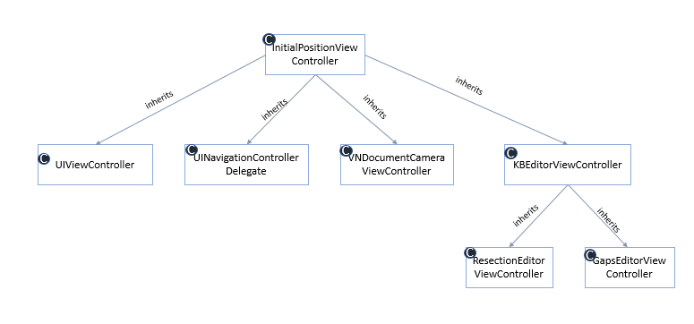

**Initial Position Popup:**

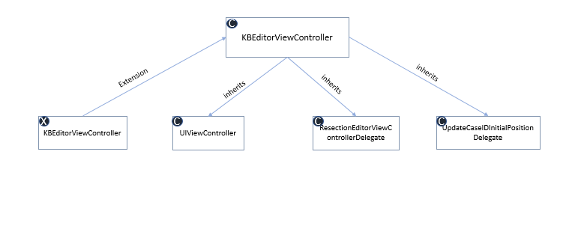

## Case Solution Module

The automated plan will be generated considering the following inputs: pre-operative data, Surgeon Preferences (Ranges and Targets), Intra-operative data (HKA, initial gaps/laxity) depending on TKA1.0 of TKA2.0

Adjust solution parameters itself manually

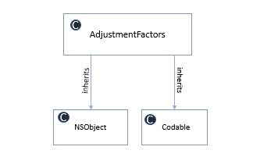

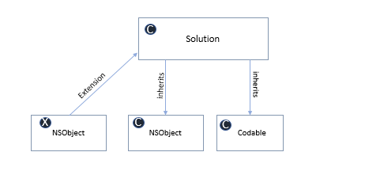

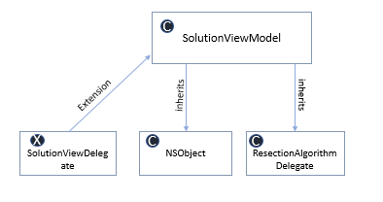

## User Preference module

Allows user to input the following planning ranges for the femoral component to be used during generation of automated implant plan:

* Coronal Alignment (Varus/Valgus)
* Transverse Alignment (I/E Rotation)
* Medial Lateral Distal
* Posterior Resections.

Allows the user to input planning targets and ranges for the tibial component to be used during generation of automated implant plan:

* Coronal alignment (Varus/Valgus)
* medial lateral tibial resections.

Allows user to input Planning targets for gaps/ laxity depending on TKA1.0 or TKA2.0

User can create custom preference with own ideal gaps.

TKA 1.0 – Gaps are incrementing with 1 mm

TKA 2.0 – Gaps are incrementing with 0.5 mm

The default values for the standard preferences are as shown in the table

|  |  |  |  |  |  |
| --- | --- | --- | --- | --- | --- |
| **Parameters** | **Units** | **Mechanical Narrow** | **Mechanical Wide** | **Individual Narrow** | **Individual Wide** |
| **Distal Femur** |  |  |  |  |  |
| Coronal Alignment Limits | deg | Neutral 0.0 | Neutral 0.0 | initial | initial |
| Medial Resection Limits | mm | 8 | 8 | 6.5 | 6.5 |
| Lateral Resection Limits | mm | n/a | n/a | 6.5 | 6.5 |
| **Posterior Femur** |  |  |  |  |  |
| Rotational Alignment Limits | deg | Neutral 0.0 | Neutral 0.0 | initial | initial |
| Medial Resection Limits | mm | 8 | 8 | 6.5 | 6.5 |
| Lateral Resection Limits | mm | n/a | n/a | 6.5 | 6.5 |
| **Proximal Tibia** |  |  |  |  |  |
| Coronal Alignment Limits | Degree | Neutral 0.0 | Neutral 0.0 | initial | initial |
| Medial Resection Limits | mm | n/a | n/a | 7 | 7 |
| Lateral Resection Limits | mm | 7 | 7 | 7 | 7 |
| **mHKA And Scoring** |  |  |  |  |  |
| Hip Knee Ankle Alignment Limits | Degree | 0 | 0 | initial | initial |
|  |  |  |  |  |  |
| Maximum Soft Tissue Release | mm | Any quadrant  5 mm | Any quadrant  5 mm | Any quadrant  5 mm | Any quadrant  5 mm |

**Min and Max ranges for preference – Mechanical Narrow (MN)**

|  |  |  |  |  |
| --- | --- | --- | --- | --- |
| **Parameters** | **Units** | **MN** | | |
| **Min** | **Target** | **Max** |
| **Distal Femur** |  |  |  |  |
| Coronal Alignment Limits | deg | Varus 2.0 | Neutral 0.0 | Valgus 2.0 |
| Medial Resection Limits | mm | 6 | 8 | 10 |
| Lateral Resection Limits | mm | 3 | n/a | 8.5 |
| **Posterior Femur** |  |  |  |  |
| Medial Resection Limits | mm | 6 | 8 | 10 |
| Lateral Resection Limits | mm | 3 | n/a | 8.5 |
| **Proximal Tibia** |  |  |  |  |
| Coronal Alignment Limits | Degree | Varus 2.0 | Neutral 0.0 | Valgus 2.0 |
| Medial Resection Limits | mm | 3 | n/a | 7 |
| Lateral Resection Limits | mm | 5 | 7 | 9 |
| **HKA And Scoring** |  |  |  |  |
| Hip Knee Ankle Alignment Limits | Degree | Varus 2.0 | 0 | Valgus 2.0 |
|  |  |  |  |  |
| Maximum Soft Tissue Release | mm | 5mm any quadrant | | |

**Min and Max ranges for preference – Mechanical Wide (MW)**

|  |  |  |  |  |
| --- | --- | --- | --- | --- |
| **Parameters** | **Units** | **MW** | | |
| **Min** | **Target** | **Max** |
| **Distal Femur** |  |  |  |  |
| Coronal Alignment Limits | deg | Varus 3.0 | Neutral 0.0 | Valgus 4.0 |
| Medial Resection Limits | mm | 4 | 8 | 11 |
| Lateral Resection Limits | mm | 2 | n/a | 10 |
| **Posterior Femur** |  |  |  |  |
| Medial Resection Limits | mm | 4 | 8 | 11 |
| Lateral Resection Limits | mm | 2 | n/a | 10 |
| **Proximal Tibia** |  |  |  |  |
| Coronal Alignment Limits | Degree | Varus 4.0 | Neutral 0.0 | Valgus 3.0 |
| Medial Resection Limits | mm | 1 | n/a | 9 |
| Lateral Resection Limits | mm | 3 | 7 | 10 |
| **HKA And Scoring** |  |  |  |  |
| Hip Knee Ankle Alignment Limits | Degree | Varus 4.0 | 0 | Valgus 3.0 |
|  |  |  |  |  |
| Maximum Soft Tissue Release | mm | 5mm any quadrant | | |

**Min and Max ranges for preference – Mechanical Narrow (IN)**

|  |  |  |  |  |
| --- | --- | --- | --- | --- |
| **Parameters** | **Units** | **IN** | | |
| **Min** | **Target** | **Max** |
| **Distal Femur** |  |  |  |  |
| Coronal Alignment Limits | deg | Varus 2.0 | LDFA | Valgus 4.0 |
| Medial Resection Limits | mm | 4.5 | 6.5 | 8.5 |
| Lateral Resection Limits | mm | 4.5 | 6.5 | 8.5 |
| **Posterior Femur** |  |  |  |  |
| Medial Resection Limits | mm | 4.5 | 6.5 | 8.5 |
| Lateral Resection Limits | mm | 4.5 | 6.5 | 8.5 |
| **Proximal Tibia** |  |  |  |  |
| Coronal Alignment Limits | Degree | Varus 4.0 | MPTA | Valgus 2.0 |
| Medial Resection Limits | mm | 4 | 7 | 9 |
| Lateral Resection Limits | mm | 4 | 7 | 9 |
| **HKA And Scoring** |  |  |  |  |
| Hip Knee Ankle Alignment Limits | Degree | Varus 4.0 | aHKA | Valgus 2.0 |
|  |  |  |  |  |
| Maximum Soft Tissue Release | mm | 5mm any quadrant | | |

**Min and Max ranges for preference – Individualised Wide (IW)**

|  |  |  |  |  |
| --- | --- | --- | --- | --- |
| **Parameters** | **Units** | **IW** | | |
| **Min** | **Target** | **Max** |
| **Distal Femur** |  |  |  |  |
| Coronal Alignment Limits | deg | Varus 3.0 | LDFA | Valgus 6.0 |
| Medial Resection Limits | mm | 2.5 | 6.5 | 10.5 |
| Lateral Resection Limits | mm | 2.5 | 6.5 | 10.5 |
| **Posterior Femur** |  |  |  |  |
| Medial Resection Limits | mm | 2.5 | 6.5 | 10.5 |
| Lateral Resection Limits | mm | 2.5 | 6.5 | 10.5 |
| **Proximal Tibia** |  |  |  |  |
| Coronal Alignment Limits | Degree | Varus 6.0 | MPTA | Valgus 3.0 |
| Medial Resection Limits | mm | 3 | 7 | 10 |
| Lateral Resection Limits | mm | 3 | 7 | 10 |
| **HKA And Scoring** |  |  |  |  |
| Hip Knee Ankle Alignment Limits | Degree | Varus 6.0 | aHKA | Valgus 3.0 |
|  |  |  |  |  |
| Maximum Soft Tissue Release | mm | 5mm any quadrant | | |

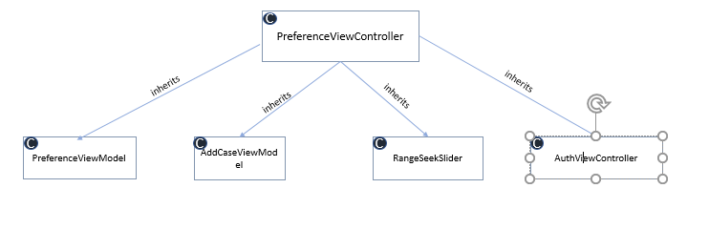

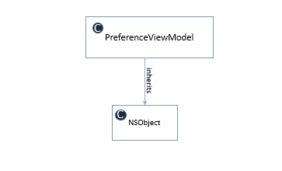

## Case Identifier module

Application allows to add the following details Case Identifier, Surgeon name, Hospital name, Surgery date.

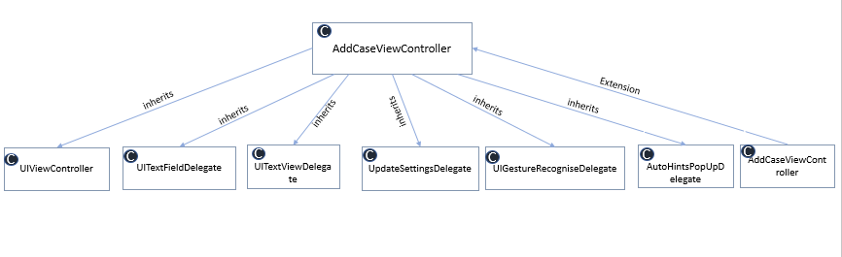

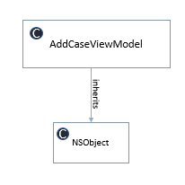

## Algorithm

**Algorithm associated objects**

* ResectionAlgorithm: An object that contains all of the logic for solving an initial position within the set limits and boundaries. Takes an InitialPosition object, stores results as an array of Solution objects.
* InitialPosition: An object that contains the initial position from all of the user controls on the Initial Position landscape view. This is the object that gets passed into the ResectionAlgorithm object.
* Solution: An object that represents a single possible solution from the ResectionAlgorithm. Also contains state information on its scoring elements and its soft tissue release requirements.
* SolutionDeltas: An object that holds the difference between the initial position and the current solution. This wasn’t added to each Solution object to reduce calculation time and state restoration overheads.
* AdjustmentFactors: An object that holds a collection of Sets. These represent all of the possible options for a single solution parameter. They are used to populate the list of possibleValues that the InteractiveLabels on the solutionView can hold.
* LimitsData: An object that holds all algorithm limits, boundaries and settings. This is passed to the ResectionAlgorithm object before it is passed an InitialPosition to set it up for the solution run.

**Rules when balancing solution**

* 1mm of adjustment on any resection surface equates to 1.29 angulation,
* 0.5mm of adjustment on any resection surface equates to 0.6 angulation,
* Adjustment to the distal medial resection affects the medial extension gap,
* Adjustment to the distal lateral resection affects the lateral extension gap,
* Adjustment to the posterior medial resection affects the medial flexion gap,
* Adjustment to the posterior lateral resection affects the lateral flexion gap,
* Adjustment to the proximal medial resection affects both the medial extension and flexion gaps,
* Adjustment to the proximal lateral resection affects both the lateral extension and flexion gaps

**Other rules of the algorithm:**

* Target gaps
  + can never have a lateral gap tighter than a medial gap
  + can never have a flexion gap tighter than a extension gap
* One set of proximal tibial medial and lateral resections are selected for one iteration
* The range of this parameters is about 12 more varus to about 12 more valgus than the initial tibial component alignment
* Overlimit calculation
  + Excess of limits or overlimits are determined from the calculated value and the initial position value. It also considers the selection of preference, the philosophy and the dynamic boundaries of its angulations and rotations.

## Target device

The application is designed to run on following target devices on supporting minimum iOS version of 14.5

* + iPhone 13
  + iPhone 13 mini
  + iPAD Air 4th gen

The application to make use of hardware and OS features as is provided by manufacturer. Any issues or the usability due to iOS features may cause limitation to the application. User may have to either restart or refresh the app to resume to normal operation.

Ex: The multi touch feature, split screen feature etc are not intended to be supported by the application

# Detailed Process Design

Not applicable

# Detailed data design

## Data flow Diagram

The flow of case data generation from the start of the case till it is stored in the cloud is as shown below

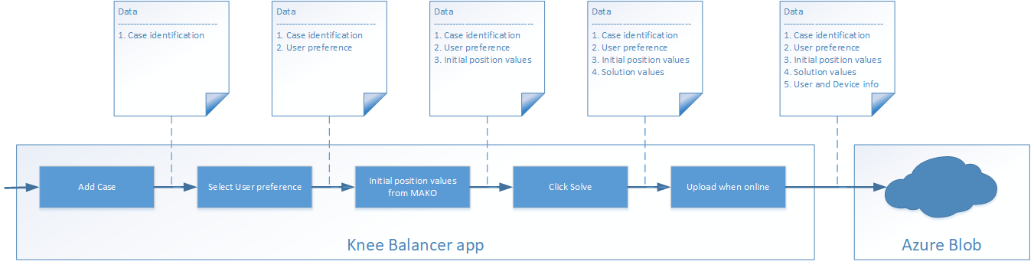

## View Preference :

Edit preference allows surgeon to edit the existing preference other than FDA-Standard and stored in DB. Edit preference will be enabled in the preference list only for newly created or cloned preference.

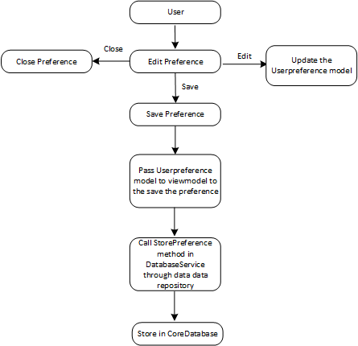

## Solution :

Solve button will be enabled after entering all the input values initialFemAlignment, initialFemRotation, initialTibAlignment, initialFixedFlexion, initialmHKAAlignment, initialaHKAAlignment, initialFemDistMedResection, initialFemDistLatResection, initialFemPostMedResection, initialFemPostLatResection, initialTibProxMedResection, initialTibProxLatResection, initialMedEXTGap, initialLatEXTGap, initialMedFlexGap, initialLatFlexGap, originalMedEXTGap,originalLatEXTGap, originalMedFlexGap, originalLatFlexGap and the selected preference. The input and preference values are passed to solveAlgorithm () method to get solutions. The solution can be seen in the solution screen. Once the solution is accepted user can exit the solution which will be stored in device database until is pushed to cloud or reaches 30days whichever is earlier. After 30 days the application is locked until.

Colour representation in the solution screen

|  |  |
| --- | --- |
| **Feature** | **Colour Code** |
| Solution Parameters | White Colour |
| Parameters different from 1st solution | Tele Colour |
| Parameters overlimit | Tele with Blue Box |
| Editable text | Enable UP/DOWN buttons |
| Non editable text | Disable UP/DOWN buttons |

## Locking and Unlock features

* If a parameter is changed, entire solution values moves to a solution-X and changed parameter is locked
* If next parameter is changed, entire solution values moves to solution-X1 and changed parameter is locked
* If next parameter is changed, entire solution values moves to solution-X2 and changed parameter is locked
* This can continue until all the parameters are locked, may be at Solution-N
* Clicking on unlock, should sequence back from Solution-N, …Solution-X1, Solution-X
* Solution parameters may appear locked from the 1st solutions it self if there are no other values are present for that parameter
* Below are the locking action and its working details.

|  |  |
| --- | --- |
| **Action** | **working** |
| Tap on any parameter | Don’t Lock |
| Tap on any parameter and make a change | Lock It |
| Tap on locked parameter and don’t change | Unlock if editable |
| Tap on locked parameter and change | Lock it again with new value |

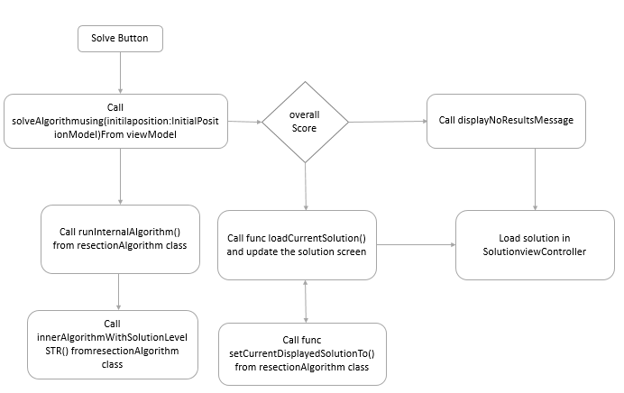

## Camera capture :

Flowcharts to visualize control flow or data flow of Camera Capture. If user tap on Camera button device camera will open and it will allow the user to take the picture. Once user captured with image it will send image to Vision Kit. Once all values are processed from the image then it will be deleted from local storage. Vision kit deploys OCR method for extracting the text or strings form the image.

For the proper image capture should be taken in precise position and with good brightness and good resolution. If the image is of poor quality the app throws error and asks to re capture.

**Ensure following while taking camera capture**

* Glare or brightness: The camera should be position is such a way that there is no light or brightness is reflecting on the MAKO monitor
* Capturing Angulation and Resection: Position the camera such a way that the camera view finder just covers 4 bones avoiding side images and external noise
* Capturing Gaps/ Laxities: Position the camera such a way that the camera view finder just covers the 4 values avoiding side images and external noise
* Capturing HKA: This needs to be entered manually
* Phone settings: The application always uses landscape mode for the proper view of the application. Whereas the camera capture uses portrait mode. The Knee balancer app guides user to use portrait mode if the phone is tilted landscape. Make sure the Auto Rotation feature is enabled in the settings.

Note: The camera capture is 80-90 % accurate and may fail if any of the above conditions did not meet properly. in those condition retake the camera capture again or enter manually

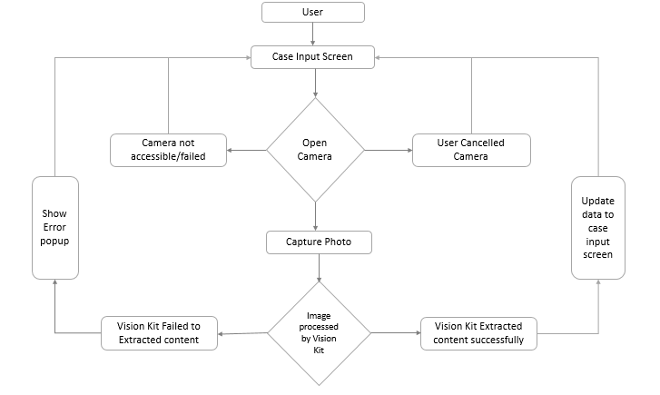

## Core DataBase

Core Data is a graphical and persistence framework, which is used in Apple devices with operating systems iOS.

**Solved Data**:

In the Application user creates a tile then case details will be store in database. After user entering the data in initial position screen, the initial position data will be store in database.

User after tap on solve button the solution data will be store in database.

**Modified Data**:

All the modified data will be stored in the database. Additionally, Case data and Logs data will be stored in database.

All the case details, solution, selected preference, and logs data will be pushed to cloud once the device is online. Post upload to cloud, current case data will be deleted permanently in the database.

If user did not upload the data within 30 days, then data will be deleted automatically from database. The application shows pop-up a every 12 hours to user when past case data are available to upload into cloud. For application upgrade, the application the data will not be lost. For App uninstallation the data will lose which is not uploaded to cloud.

## Initial Position

| Module | Description |
| --- | --- |
| InitialPositionViewController | The class contains the initial position from all the user controls on the Initial Position landscape view. The initial position object that gets passed into the ResectionAlgorithm object |
| InitialPositionViewModel | This class is used to calculate all the image transform and image rotation required by the InitialPositionViewController. |
| InitialPositionValidator | This class is used to validate the initialPositionModel. |

## User preference

| Module | Description |
| --- | --- |
| PreferenceViewController | This class is used to display the standard preference, create new custom preference and delete the custom preference. Also display UI for preference screen. |
| PreferenceViewModel | This class is used for fetching and save the created, edited preferences. |

## Solution

| Module | Description |
| --- | --- |
| SolutionViewController | This class is used to display solutions from the ResectionAlgorithm based on the input provided on the initial position and selected preference. |
| Solution | An object that represents a single possible solution from the ResectionAlgorithm. Also contains state information on its scoring elements and its soft tissue release requirements. |

## Upload Module

|  |  |
| --- | --- |
| Module | Description |
| Knee Balancer Backend-Cloud | Sync the data from the iOS app over internet whenever requested and store for further analysis and retrieval |

**From Front end**

* Authenticate the app using the Stryker credentials
* Configure automatic upload whenever come online
* Show reminder to user if the data is not uploaded for every 12 hrs. Up to 30 days.
* Small dashboard for upload details in the app to show
* Total past case details uploaded
* Total past case details pending for upload
* Data push to blob storage – case data, logs data.
* If upload fails retry until the success acknowledgement is received. The backend will return with the right acknowledgement based on the payload.

**From Backend**

* Azure cloud services and Azure Blob storage
* Azure storage API’s
* Users who have permission to install our app from stryker app store. Need to provide those users as Storage Account key operator Service Role in storage account IAM to authorize storage account and access for regenerate keys.
* Provide Post marketing user as AzureBlobDataReader Role to read the case data in portal. This user cannot be able to Edit/Delete the case data in portal.
* Blob Life Cycle Management: Deleting the case Data and Log files for every 90 days.
* Data dump for analysis.

The sequence of operation while the data is being uploaded to cloud is as shown in the diagram below.

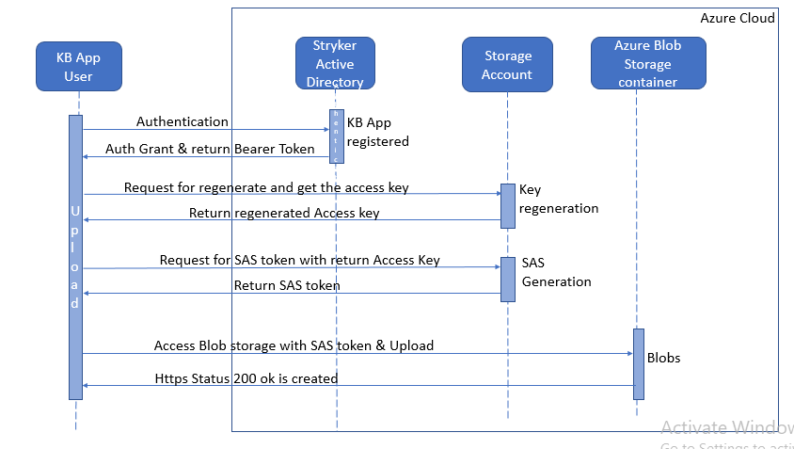

## Backend -Cloud

**Azure Blob Storage**

Azure Blob storage is Microsoft's object storage solution for the cloud. Blob storage is optimized for storing massive amounts of unstructured data. Unstructured data is data that doesn't adhere to a particular data model.

**Blob storage details**

Storage account - Stryker

Container - Knee Balancer

Blob - * JSON (case data, logs)

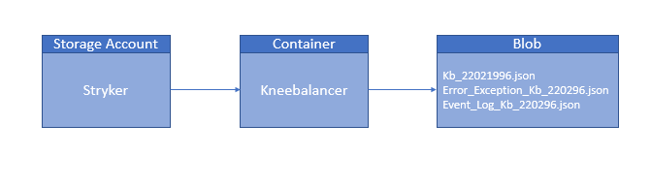

|  |  |
| --- | --- |
| Units | Description |
| API’s | Azure blob storage providing direct API’s to the upload the data on cloud. |
| Azure Storage Account | Azure storage account contains all of your Azure Storage data objects i.e. files. The storage account provides a unique namespace for your Azure Storage data that is accessible from anywhere in the world over HTTP or HTTPS. |
| Azure blobStorage Container | To store the data as json file in Azure cloud-azure blob storage for future retrieval |
| Storage account Access Key | By using Storage account access key API is used for generating the key to generate SAS token to upload data in blob storage. |
| Shared Access Signature (SAS) Token | Generating SAS token by using API based on application Id. To access storage account and upload the blob. SAS token will expire within an hour. For every upload generating the new SAS. And it is not storing anywhere in app. |

## Authentication Module:

The Microsoft Authentication Library (MSAL) enables developers to acquire tokens from the Microsoft identity platform to authenticate users and access secured web APIs. And its token will expire in within short period of time (i.e., half an hour). It can be used to provide secure access to Microsoft Graph, other Microsoft APIs, third-party web APIs.

|  |  |  |  |
| --- | --- | --- | --- |
| *SDD ID* | Module | Description | SAD ID |
| SDD106 | Knee Balancer Authentication | Enables developers to acquire tokens from the Microsoft identity platform in order to authenticate users and access secured web APIs. | SAD107 |

# SOUP items

Refer [SAD] for list of SOUP

Refer [SOUP] for detail analysis of each SOUP items

# SECURITY

Refer: [PSRT] for more details.

The app uses the iOS platform which publishes the apps with greater security from the manufacturer using provisioning files and certificates.

The app is installed from dedicated app store limited to Stryker users and to limited Stryker group as assigned by the admin

The data for storing in device and to transit does not contain any sensitive data such as patient information, credentials or certifications. However, the data is transmitted and stored in Azure cloud with the security and encryption as provided by the Azure cloud.

Identify jailbroken device and block user to use the application displaying message

If unauthorised user tries to sing-in display a message to contact Stryker

# XCODE Configuration

|  |  |
| --- | --- |
| IDE | DESCRIPTION |
| Xcode Configuration | XCode version used: v13.4.1  In the build configuration, enabled binary protection with safe compilation by ensuring stack protection, PIE support, Automatic Reference Counting (ARC) and setting byte-code minification.    Followed binary protection followed in the compilation process with design document. |

# Document Revision History:

|  |  |  |  |
| --- | --- | --- | --- |
| Revision  Level | Revision Date | Effective Date | Reason and Description of Revision |
| 0 | 29-Jul-22 | 29-Jul-22 | Initial document |
| 1 | 7-Sep-22 | 7-Sep-22 | SDD100 - message updates and hamburger menu updates  SDD101 - case settings to select surgeon and custom preference  SDD102 and sec 7.4 - Replaced undo to unlock and 30 days lock when exit solution  SDD103 and sec 5.4 - Update preference ranges  SDD104 - Confirmation with user on saved case details  SDD102 and Sec 9 - Security updates for jailbroken device and unauthorised user  Sec 10 - Upgraded to latest XCode version  Sec 5.6 - Included overlimits calculation details in algorithm  Sec 7.5 - updated camera capture details |

# Appendix

## Example of Case file

{

"caseDetails": [{

"UserData": {

"mpsId": "-",

"mpsName": "xxxxxxxx",

"mpsEmailId": "xxxxxxxx@stryker.com"

},

"AddCase": {

"HospitalName": "200",

"SurgeonName": "",

"ExitTime": "2022-07-20 05:26:21 +0000",

"SelectedPreference": "Mechanical Wide - MW",

"inputSystem": "-",

"legAlinment": "Left Leg",

"surgeryDate": "20 July 2022",

"CaseID": "D04C2CE8-41C0-444F-9FAB-BCAD8A4ADF9D",

"SolveTime": "2022-07-20 05:26:10 +0000"

},

"UploadDetails": {

"EpochTime": 1658294781.431668,

"UploadTime": "2022-07-20 05:26:21 +0000",

"DeviceTimeZone": "Asia\/Kolkata"

},

"Solution1": {

"caseSolution": {

"FemurLaterlResection": "7.0",

"STRLE": "0.0",

"STRME": "0.0",

"MedialFlexionGap": "20.0",

"FemurPosteriorLateralResection": "7.0",

"TibiaMedialResection": "7.0",

"LaterlExtensionGap": "20.0",

"STRMF": "0.0",

"FemurAlgnmentAngle": "0.0",

"FemurPosteriorMedialResection": "7.0",

"FemurMedialResection": "7.0",

"FemurRotationAngle": "0.0",

"LateralFlexionGap": "20.0",

"MedialExtensionGap": "20.0",

"STRLF": "0.0",

"HKAAngulationVarus": "0.0",

"TibiaAlignmentAngle": "0.0",

"TibiaLaterlResection": "7.0"

},

"caseInput": {

"LaterlExtensionGap": "20.0",

"TibiaLaterlResection": "7.0",

"FemurPosteriorMedialResection": "7.0",

"FemurLaterlResection": "7.0",

"TibiaAlignmentAngle": "0.0",

"FemurRotationAngle": "0.0",

"MedialExtensionGap": "20.0",

"LateralFlexionGap": "20.0",

"mHKAAngulationVarus": "0.0",

"mHKAFlexion": "0.0",

"TibiaMedialResection": "7.0",

"FemurPosteriorLateralResection": "7.0",

"MedialFlexionGap": "20.0",

"FemurAlgnmentAngle": "0.0",

"FemurMedialResection": "7.0"

},

"preference": {

"PreferenceName": "Mechanical Wide - MW",

"MedialFlexionGap": "20.0",

"LateralFlexionGap": "20.0",

"MedialExtensionGap": "20.0",

"LateralExtensionGap": "20.0"

}

},

"AcceptedSolution": {

"caseSolution": {

"MedialFlexionGap": "20.0",

"STRLE": "0.0",

"LateralFlexionGap": "20.0",

"TibiaAlignmentAngle": "-0.6",

"FemurAlgnmentAngle": "0.6",

"FemurMedialResection": "7.0",

"TibiaMedialResection": "7.0",

"FemurPosteriorMedialResection": "7.0",

"MedialExtensionGap": "20.0",

"STRLF": "0.0",

"STRMF": "0.0",

"STRME": "0.0",

"TibiaLaterlResection": "6.5",

"HKAAngulationVarus": "0.0",

"FemurLaterlResection": "7.5",

"FemurRotationAngle": "1.9",

"FemurPosteriorLateralResection": "5.5",

"LaterlExtensionGap": "20.0"

},

"caseInput": {

"FemurMedialResection": "7.0",

"TibiaMedialResection": "7.0",

"FemurRotationAngle": "0.0",

"MedialFlexionGap": "20.0",

"FemurPosteriorMedialResection": "7.0",

"LateralFlexionGap": "22.0",

"LaterlExtensionGap": "20.0",

"FemurAlgnmentAngle": "0.0",

"mHKAAngulationVarus": "0.0",

"mHKAFlexion": "0.0",

"MedialExtensionGap": "20.0",

"FemurLaterlResection": "7.0",

"TibiaAlignmentAngle": "0.0",

"FemurPosteriorLateralResection": "7.0",

"TibiaLaterlResection": "7.0"

},

"preference": {

"LateralExtensionGap": "20.0",

"LateralFlexionGap": "20.0",

"PreferenceName": "Mechanical Wide - MW",

"MedialFlexionGap": "20.0",

"MedialExtensionGap": "20.0"

}

},

"UniqueId": {

"DeviceId": "B1BE2DDC-0769-4B4C-8A03-BD471787E029",

"uuid": "D04C2CE8-41C0-444F-9FAB-BCAD8A4ADF9D"

}

}]

}

## Example of Error or Exception logs file

[{ "Description": "The operation couldn’t be completed. (KneeBalancer.UpcomingCasesViewController.RikhError error 1.)"

}, { "Description": "The operation couldn’t be completed. (KneeBalancer.UpcomingCasesViewController.RikhError error 0.)"

}]

## Example of Events log file

[{

"caseId": "",

"timeStamp": "1658220329.4931622",

"deviceId": "B1BE2DDC-0769-4B4C-8A03-BD471787E029",

"properties": {

"Launched Knee Balancer App": true

},

"event": "App Launch"

}, {

"caseId": "B41A8E7B-BAA0-43BC-AF3C-440016B7D9B1",

"timeStamp": "1658220380.1815171",

"deviceId": "B1BE2DDC-0769-4B4C-8A03-BD471787E029",

"properties": {

"Case is added successfully by tap on Proceed button": true

},

"event": "E2 - Proceed Action in Add case Screen"

}, {

"caseId": "B41A8E7B-BAA0-43BC-AF3C-440016B7D9B1",

"timeStamp": "1658220395.121852",

"deviceId": "B1BE2DDC-0769-4B4C-8A03-BD471787E029",

"properties": {

"Navigated successfully from Initial position to upcoming case screen after storing the changes in DB": true

},

"event": "E6 - Home Action in Initial position screen"

}, {

"caseId": "",

"timeStamp": "1658225230.7843509",

"deviceId": "B1BE2DDC-0769-4B4C-8A03-BD471787E029",

"properties": {

"Launched Knee Balancer App": true

}]

## Complete event list captured in the application

|  |
| --- |
| **Events logs** |
| Launched Knee Balancer App |
| Case is added successfully by taping on Done button |
| Case is added successfully by tap on Proceed button |
| Reset the field successfully |
| Navigated to Initial position from Upcoming screen successfully |
| Searching the case in Upcoming case screen successfully |
| Navigated successfully from Initial position to upcoming case screen after storing the changes in DB |
| Navigated successfully from Initial position to upcoming case screen |
| Navigated successfully from Initial position to Add case screen |
| Settings popup displayed successfully |
| Selected preference option and Set default preference Popup shown successfully |
| Reset alert shown successfully |
| Reset the field successfully |
| Alert with Solution is shown with Ok button |
| Navigated successfully from Solution screen to upcoming case screen |
| Deviation popup shown successfully for the Solution |
| Delta value for the solution shown successfully |
| Taped on Go to preference and navigated to preference screen successfully |
| Taped on Close icon and Set default preference screen dismissed successfully |
| Selected preference successfully |
| selected the preference as default successfully |
| Created New Preference successfully |
| Cloned Preference successfully |
| Edited Preference successfully |
| Deleted Preference successfully |
| Navigated successfully from preference screen to Initial position Successfully |
| Incremented the gap values successfully |
| Decremented the gap values successfully |
| Time taken to calculate algorithm |